ND Cares Executive Committee Meeting
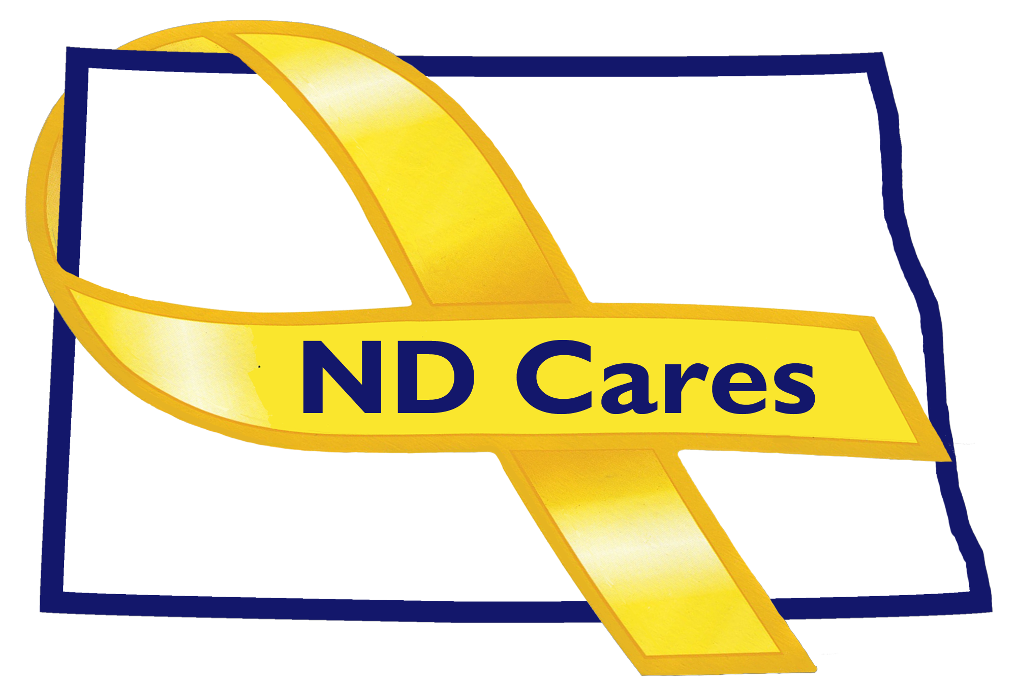
January 7, 2021

Attendees: Connie Sprynczynatyk (virtual), Cindy Whitesell (virtual), Joyal Meyer (virtual), Brian Watters (Virtual) LTC Shawn Flemmer (virtual), BG Jackie Huber (virtual), David Becker (virtual), Dale DeKrey (virtual), Pam Sagness (Virtual) Michelle Panos
Absent: Davina French, Breton Weintraub, Lonnie Wangen
1. Opening. Connie briefly opened the meeting.

2. Minutes. Minutes from the December 3, 2020 meeting where accepted as written.

3. Guest Presentation: Sara Blazek from Army Survivor Outreach discussed her program that is funded through the National Guard Bureau. She services about 300 survivors in North Dakota from all military components and status (KIA, suicide, accidental death, illness, and homicide). Support is specialized to each family. They also provide resources and referral to programs such as grief and bereavement counselling, financial counselling, benefit management, educational and a survivor connection network. If a survivor moves to a new state, that state’s survivor program will continue to provide services. The annual remembrance weekend will take place at the end of July in Bismarck and will include guest speakers, an opportunity for families to connect or reconnect. No official mentor training, but the families provide mentorship to each other. TAPS is a separate national program that offers online peer mentor training and period in-person regional training. Michelle asked if it would be beneficial to offer an in-person training, here is North Dakota, either in conjunction with or separate from the remembrance weekend. Sara was open to discussing the prospect.
4. Old Business
- Michelle stated that there was not change to the number of ND Cares Businesses (19) and Communities (48) and Reconnected Communities (12).
- Michelle reviewed the budget where she noted that 47.8% of the biennial budget remains. She predicted more will be spent on travel and printing in 2021
- ND Cares donations in the NDNG Foundation account now total $13,915.13 with the addition of a donation from Blue Cross Blue Shield of North Dakota. $1384.87 of the $2500 from Woodruff Foundation was distributed: $884.87 for masks and hand sanitizers and $500 in distributions from the NDNG Emergency Relief Fund.
- Michelle also stated that the action plans for identified gaps in Anti-stigma messaging will be further refined and reported out in the coming months.
- New Business

- Michelle presented a draft of the revised strategic plan agreed upon by the small working group of Executive Committee members on December 8, 2020. The one overarching goal is to break down barriers to behavioral health services and the three objectives deal with building awareness of resources, strengthening peer-to-peer support and training, and developing a anti-stigma communications plan.
- Michelle presented a draft of the 2020 North Dakota Military Data Book.
- Michelle offered to send weekly legislative updates with a tracking spreadsheet to the executive committee/coalition about pieces of bills relevant to our mission. Brian provided a link to the ND Veterans Administration legislative page that Lonnie will keep updated during the session. Connie stated that we could try it for a few weeks to see if the information is useful to the members.
- Executive Committee Updates:
  - Brian from the NDVA reported that his agency is currently focusing on restoring the 30% budget cut from last session and legislation that establishes a pilot veterans’ court in Grand Forks County. Pam Sagness stated that she sits on the Supreme Court board that approves new courts, as a clinical consultant.
  - Dale from the Fargo VA reported on the new (CRRC) community resources and referral center that opened in Fargo. He also stated the Fargo VA was approved as a priority site for the construction of a Fisher House that hosts families of VA patients, even if the veteran is being treated in a local hospital other than the VA. Lastly he reported on the distribution COVID-19 vaccines to healthcare personnel, the CBOCS, homeless veterans and veterans 75 years and older with certain health conditions.
  - Joyal from ND Department of Health reported that the ND Suicide Prevention Coalition will hold their annual conference virtually sometime in February. Presenters will cover topics on the farming community, children and adolescents having difficulty with isolation due to COVID.
  - Pam Sagness from the ND Behavioral Health Division reported that the primary focus is continuing to “put the person first” focusing on family needs instead program needs requiring a reallocation of funds and changing processes. She doesn’t see current threat of budget cuts, and hoping the legislature will continue to support Free Through Recovery expansion and Substance Use Disorder Vouchers. Pam also reported the 460 people have completed peer support training and more than 30 have been officially certified since the certification program began in July of 2020. Lastly, Pam mentioned that she hopes the session does not result in policy changes that will alter the comprehensive strategy laid out in the 2018 Human Services Research Institute Report, which the agency is currently implementing. Community Connect offers outcome-based reimbursement of providers for clients’ care coordination and peer support for individuals with a behavioral health issue. This program hopes to reach people “before” they reach the criminal justice system. They will be reaching out to more families at risk of being involved in the child welfare system before there is abuse.
  - LTC Flemmer from the NDNG discussed anti-stigma and working with Nathan Griffin to tell his story about surviving suicide. The Guard is working with him to use half his drill time to address units to address stigma. “The We Care” campaign was also launched to broadcast all the resources that our available to service members. Resource cards were also distributed noting services such as suicide preventions, substance abuse, counseling, chaplains office, sexual assault, military outreach etc.
  - Connie stated that there are no Legislative events this year to due COVID.
- Upcoming Events:
- ND Suicide Prevention Coalition Annual Meeting – TBD Feb. 2021
- TAPS Survivor Peer Mentor Online Training – Jan. 7, 10, 15, 20, 21, 28 (requires application approval)
- ND Behavioral Health Peer Support Trainings (Mental Health/Substance Abuse) in Grand Forks, Devils Lake, Jamestown – Jan. 11 and 15.
- Next meetings: The next Executive Committee meeting will be February 4, 2001. The committee agreed to hold the next full Coalition meeting after the legislative crossover date of February 26.

