ND Cares Executive Committee Meeting
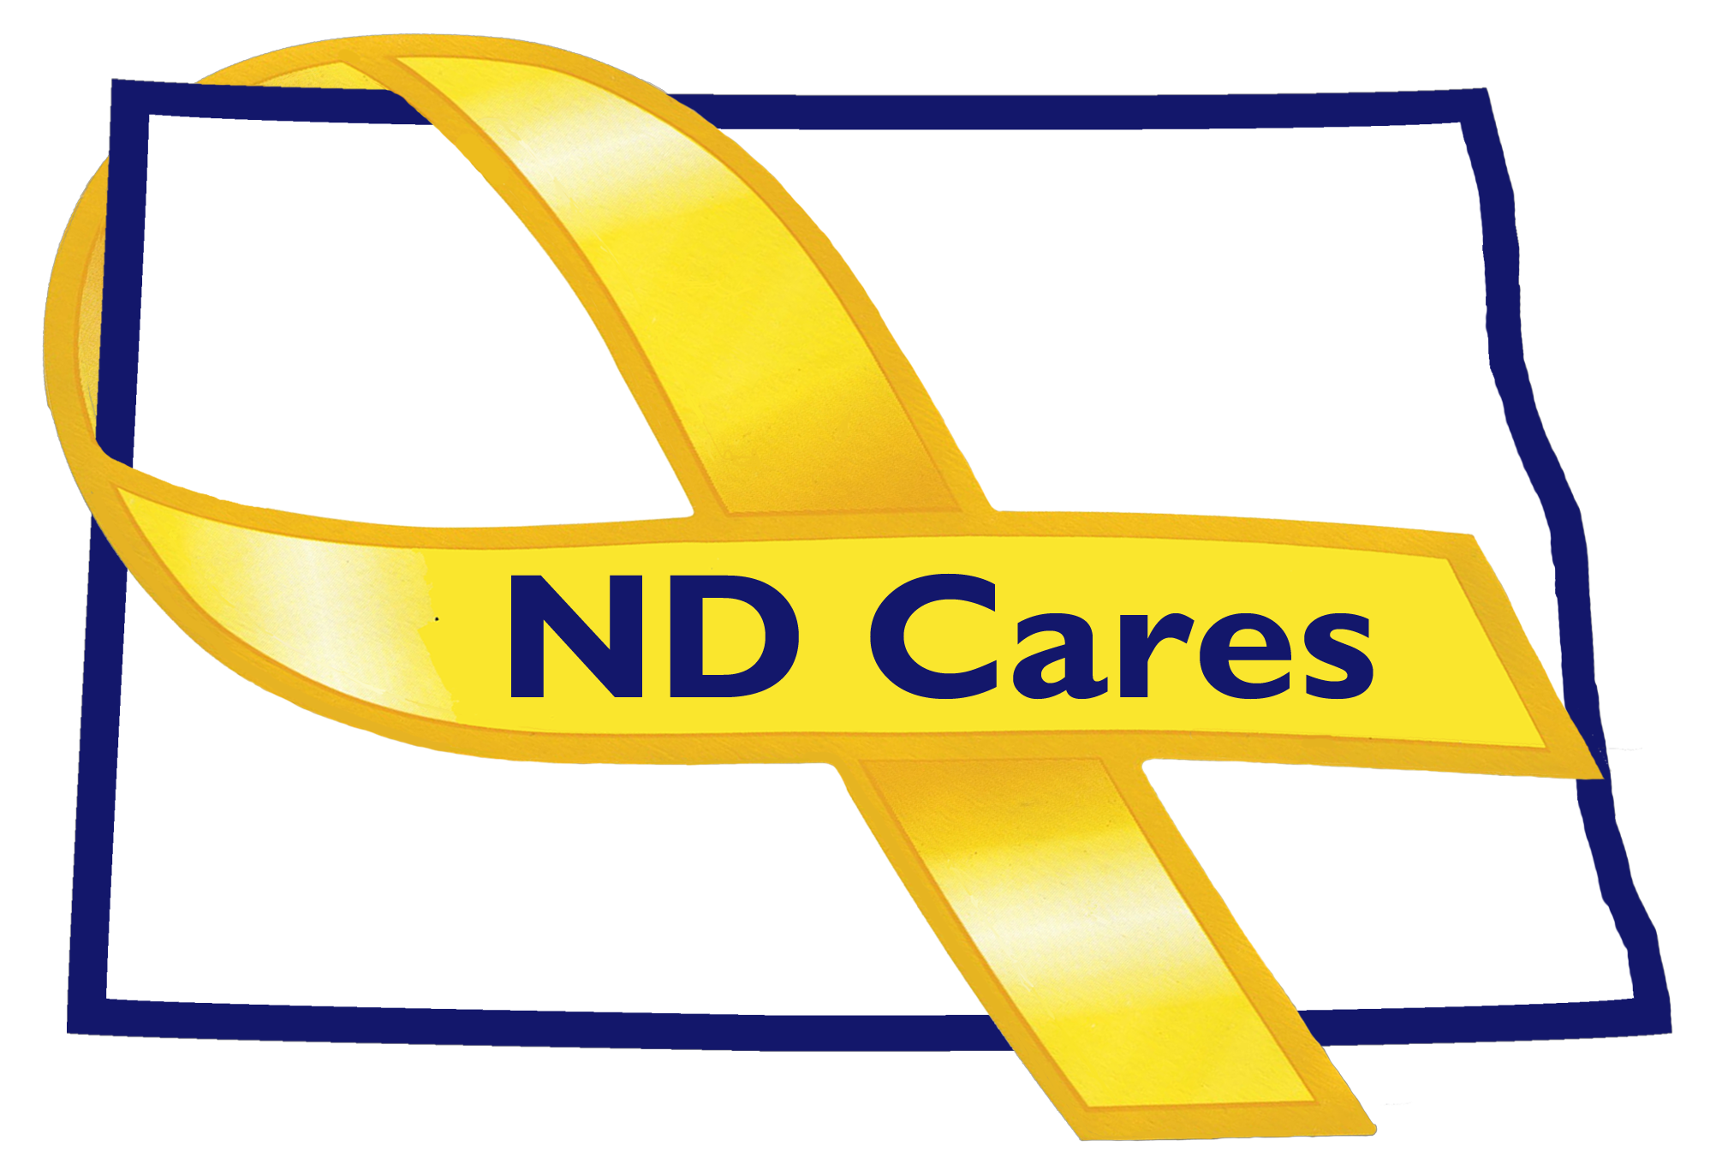
Dec 20, 2019

Attendees: Connie Sprynczynatyk, Dr. Breton Weintraub (Telephone), Lonnie Wangen (Telephone), BG Jackie Huber, Cindy Whitesell (Telephone), Pam Sagness, (Telephone), David Becker (Telephone), LTC Pat Flanagan, Shawn Flemmer, Davina French, Darcie Handt, and Joe Faller.

Absent: Joyal Meyer.

1. Minutes. Minutes from the October 23, 2019 accepted as written.

2. Presentation. Grant Wilz & Jasmin Yoder from the “We Honor Veterans” CHI Hospice Program provided an overview of their program and how it supports Veterans and their family members.

3. Due outs.
- No due outs to cover.

4. Old Business/Tasks Pending.
- Darcie discussed the Community Re-connect program. Currently have 48 communities and will try to meet with each of them, face to face, to discuss where they are and how we can help support them and their program. Also discussed the upcoming Clergy Training program provided by the VA. Upcoming training will be conducted on January 30, 2020 in Medora ND.
- Darcie provided an update to the strategic plan. Still working with Firstlink to populate their database. Continue to work with Katie Fitzsimmons to get Military Culture Training in the ND University System.

5. New Business:
- Discussed the updated strategic plan goals and objectives developed from the strategic planning session. No change was made to who we support, the mission, or the priorities. Updated goals and objectives were presented to the committee and accepted with no change.
- Reduce barriers to the use of Behavior Health services (Goal)
- Expand awareness of resources within each region (Obj)
- Build collaborative outreach among coalition partners (Obj)
- Develop a peer to peer network for the military community (Obj)
- Initiate a coalition wide stigma reduction campaign (Obj)

- All changes to the Executive Committee membership have been submitted to the Governor’s Office. The Governor’s website will be updated when all new members have been approved.
- Nothing to update on the website or facebook.
- The ND Suicide Prevention Coalition annual conference is scheduled for January 22, 2020 at the BSC Career Academy. Flyers have been distributed around the state.

- EC Members updates:
  - Cindy did not have an update.
  - Lonnie talked about the Commissioners Challenge and his intent to start a more organizational emphasis in the New Year.
  - Breton; the Fargo VA took a pass as this is his first meeting and wanted to get to know the group and what information would need to be presented for future meetings.
  - Pam discussed the Peer support regulation, required by July 1, 2020, is in draft. Public meetings will be coming soon and feedback is highly encouraged. The 1915i will be going live on July 1st also. The behavior health conference ended in November with over 550 attendees. Just completed a state tour of all regions to describe changes coming with new legislation. Recovery Talk phone line, manned by a Peer support specialist just started. Also, a pilot peer support program teamed with Sanford Health, has started for pregnant moms or parents who are struggling with addiction called “Call Kay”, currently only in Bismarck
  - BG Huber the Command Resilience Program will be kicking off in February in the Army National Guard. This program has very similar objectives to that of ND Cares. She also talked about her testimony, this week, house bill 1101 about how the ND National Guard can accept funds from the ND National Guard Foundation or other like foundations to help support survivor outreach and youth programming. No funds have been received yet.
  - This will be LTC Flanagan’s last meeting. Talked about their internal pilot, with Kognito, funded by the National Guard Bureau. Will be conducting a small pilot with hopes to expand. This training will help build skills in individuals to help others in need. Working with tribal entities to expand Suicide Prevention Training. Jennifer Lynn is stepping down from her position with the ND National Guard.
- Dave Becker did not have an update to provide.
- Darcie shared information about the Wellington, in Minot ND, and their wall displaying all their Veteran residence. A wonderful display for those residents who have served.

6. Upcoming events:

  - ND Suicide Prevention Coalition Annual Conference, January 22nd, 2020. Bismarck, ND
  - Community Clergy Training, January 30th, 2020. Medora, ND.

Respectfully submitted,

Darcie Handt, Executive Director

