ND Cares Executive Team
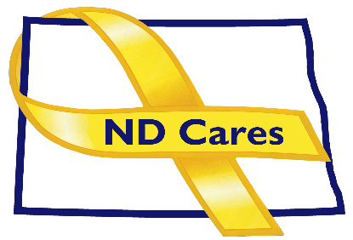
AGENDA
10:30 a.m. – Noon
August 3, 2023
Virtual

Virtual Meeting Call – In: 701-328-0950 Conference ID: 485 695 444#
Click here to join the meeting via Microsoft Teams on computer or mobile app
Chair – Shelly Sizer Co-Chair – Cindy Whitesell

- OPENING
  - Comments (Shelly or Cindy)
  - Approve Executive Committee meeting minutes from July 6, 2023.

- PRESENTATION: Lezlie Poole, Rosalynn Carter Institute for Caregivers: Disaster Preparedness Toolkit
- NEW BUSINESS
- Executive Committee Member Updates
    - Co-Chairperson
    - ND DVA
    - Regional VA, Fargo
    - ND Dept. of Health
    - ND Dept. of Human Services, Behavioral Health Division
    - ND National Guard
    - Army Reserve Ambassador for North Dakota
    - Chairperson

- OLD BUSINESS
  - ND Cares Business (23) /Community (58) Update
- Dakota Care Home, Aug 9 TBD
  - Governor’s Challenge Update
  - North Broadcasters Association PEPs
    - COMPACT Act
- UPCOMING EVENTS
- Survivor Outreach Services: Remembrance Weekend, Aug 5-7, Ramada, Bismarck
- Counseling on Access to Lethal Mean training: Aug. 8, RJB Armory, Bismarck
- Brats for the Brave: Sept 6, Kirkwood Mall, Bismarck
- FirstLink: Applied Suicide Intervention Skills Training, Sept 19, Fargo
- Governor’s Challenge Post Implementation Site Visit.: Aug. 22-23, Bismarck & Fargo
- 911 Remembrance Observance: Sept 11, GWOT Memorial Fraine Barracks, Bismarck
- ND Suicide Prevention Coalition: Annual Conference (in-person/virtual) Sept 14, Bismarck Career Academy
- ACOVA: Sept. 14-15, Veterans Club, Steele
- NDNG Retiree Weekend: Sept 15-17, CGTC Devil’s Lake
- Bismarck Stand Down: Aug. 24, AMVETS Club
- Brain Injury Network: Powerful Tools for Caregivers (Zoom), Aug 22-Sept 26
- FirstLink: Suicide Risk Assessment: Live One Hour Webinar, Sept 28
- AFSP Out of the Darkness Walks: Sept – Oct, Various Locations
- ND County & Tribal VSO Training: Oct 2-5, Baymont Inn, Mandan
- Behavioral Health & Children Services Conference (in-person/virtual): Oct 24-26, Bismarck

- NEXT MEETING DATES
- Coalition Mtgs 2023: Sept 7, Dec 7, from 1:00-4:00 pm.
- Executive Committee Mtgs 2023: Oct 5, and Nov 2, from 10:30-Noon.

