ND Cares Executive Team
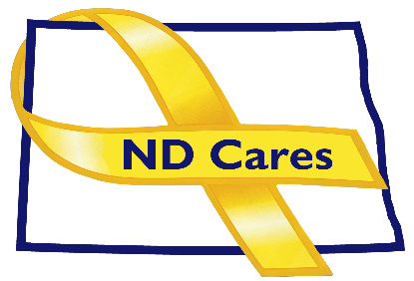
AGENDA
10:30 a.m. – Noon
June 2, 2022
Fraine Barracks – Bldg. 30 - Bismarck, ND

Virtual Meeting Call – In: 701-328-0950 Conference ID: 600 010 848#
Click here to join the meeting via Microsoft Teams on computer or mobile app
Chair – Shelly Sizer Co-Chair – Cindy Whitesell

- OPENING
  - Comments (Shelly)
  - Approve Executive Committee Meeting minutes from April 7, 2022.
- PRESENTATION: Bridges for the Fallen, Rob Mador
- NEW BUSINESS
- Executive Committee Member Updates
    - Co-Chairperson
    - ND DVA
    - Regional VA, Fargo
    - ND Dept. of Health
    - ND Dept. of Human Services, Behavioral Health Division
    - ND National Guard
    - Army Reserve Ambassador for North Dakota
    - Chairperson

- OLD BUSINESS
  - ND Cares Business Update
    - Current number of businesses: 22
      - The Healing Center Counseling & Consulting
      - Vision West (presentation pending)
  - ND Cares Community Update
    - Current number of communities: 51
  - Strategic Plan Update
  - Governor’s Challenge
  - TRICARE

- UPCOMING EVENTS
- TAPS Peer Mentor Virtual Training: June 5, 2022, 3:00 PM-7:00 PM
- First Link ASIST Training: June 8-9, Fargo: $250
- First Link Suicide Risk Assessment Webinar (C-SSRS): Sept. 29
- First Link SafeTalk: June 3 (Bismarck), June 4 (Dickinson)
- Minot Military Affairs Committee: June 2
- ACOVA Meeting: August 11-12 or 18-19
- Grand Forks Military Affairs Committee: June 15
- Fargo/Moorhead Military Affairs Committee: 11 a.m. June 17
- Devils Lake Military Affairs Committee: June 23
- Williston Military Affairs Committee: June 3
- Governor’s Challenge Academy Site: June 7-9
- ND Behavioral Health & Children and Family Conference: Oct. 11-13, Fargo
- Mental Health Advocacy Network Podcast Episode 1: Everything You Should Know About Your State Hospital:
- NEXT MEETING DATES
- ND Cares Coalition Meeting, Aug 4, 2022
- ND Cares Executive Committee Meeting (proposed) July 7, 2022, 10:30-Noon.

