ND Cares Executive Team
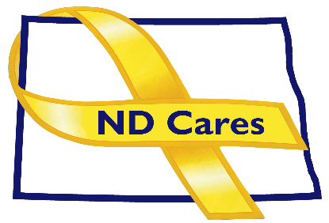
AGENDA
10:30 a.m. – Noon
January 12, 2021
Fraine Barracks – Bldg. 30 - Bismarck, ND

Virtual Meeting Call – In: 701-328-0950 Conference ID: 325 033 732 #
Click here to join the meeting via Microsoft Teams on computer or mobile app
Chair – Connie Sprynczynatyk Co-Chair – Cindy Whitesell

- OPENING
  - Comments (Connie)
  - Approve Executive Committee Meeting minutes from November 17, 2021.

- PRESENTATION: TBD
- OLD BUSINESS
  - ND Cares Business Update (ED)
    - Current number of businesses: 19
  - ND Cares Community Update (ED)
    - Current number of communities: 51
  - Strategic Plan Update
  - Broadcaster Association Spot Update
  - Tricare

- NEW BUSINESS
- Executive Committee Member Updates
    - Co-Chairperson
    - ND DVA
    - Regional VA
    - ND Dept. of Health
    - ND Dept. of Human Services, Behavioral Health Division
    - ND National Guard
    - Army Reserve Ambassador for North Dakota
    - Chairperson

- UPCOMING EVENTS
- TAPS Peer Mentor Virtual Training: Jan 24
- American Legion State Convention: Jan. 28-29, Ramkota Hotel, Bismarck
- First Link Assist Training: Jan 26, First Link Offices, Fargo
- First Link Suicide Risk Assessment: Live One Hour Webinar: Feb 3, Fargo
- Minot Military Affairs Committee: Dec 2, Minot
- SD State University 2022 Addiction Conference, Virtual: Feb 7-11
- Behavioral Health Stress Mgt and Self Care After Loss: Feb 15
- ACOVA Meeting: Feb 10-11, Veterans Club, Steele
- ND Suicide Prevention Coalition 5th Annual Conference: Feb 16, Bismarck Career Academy
- Grand Forks Military Affairs Committee: Feb 16
- Fargo/Moorehead Military Affairs Committee: Feb 17
- Devils Lake Military Affairs Committee: Feb 24
- NEXT MEETING DATES
- ND Cares Coalition Meeting, May 5 or 10, 2021
- ND Cares Executive Committee Meeting (proposed) Mar 9, 2021.

