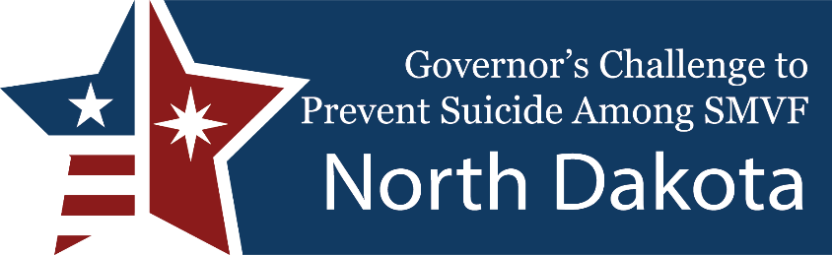
The Governor’s Challenge is a partnership among the U.S. Department of Veterans Affairs, the U.S. Department of Health & Human Services’ Substance Abuse and Mental Health Services Administration and the State of North Dakota to bring together community leaders and state agencies to prevent suicide among Service Member, Veterans, and their families.
The North Dakota Governor’s Challenge Team developed strategic action plans to prevent Veteran suicide using evidence-based methods within key priority areas.
Core team organizations include ND Cares (team lead), VA Fargo, ND Dept. of Veterans Affairs, ND National Guard, FirstLink, ND Dept. of Health & Human Services, ND Suicide Prevention Coalition, University of ND (ND HOPES), American Foundation for Suicide Prevention, and Mental Health America of ND.
Priority Area 1: Identify SMVF and Screen for Suicide Risk
- Better vital records data to look for trends and target interventions. Legislation passed to allow ND Dept of Veterans Affairs access to records for all military-related suicide deaths.
- Promote community provider screening for suicide when presented with Service Members, Veterans, and their families.
- Promote Suicide Prevention Training to community providers. (S.A.V.E., Star Behavioral Health Providers Training, Military Culture training via PsychArmor.)
Priority Area 2: Promote Connectedness and Care Transitions
- Distribute a toolkit for community providers to interface with the VA if a veteran presents at a community provider.
- Recruit veterans to complete the state’s certified peer support training.
- Provide current state-trained peer support specialists with military culture training via PsychArmor.
Priority Area 3: Promote Lethal Means Safety & Safety Planning
- Promote gun locks and medicine safe storage. VA will give gun locks to any veteran or servicemember.
- Promote Counseling on Access to Lethal Means (CALM) training with safety planning to community
providers and the general public.
- Recruit licensed firearm sellers, shooting ranges, etc. to offer suicide prevention information or safe
storage at their facility during a suicidal episode.

